SITE PHOTOS

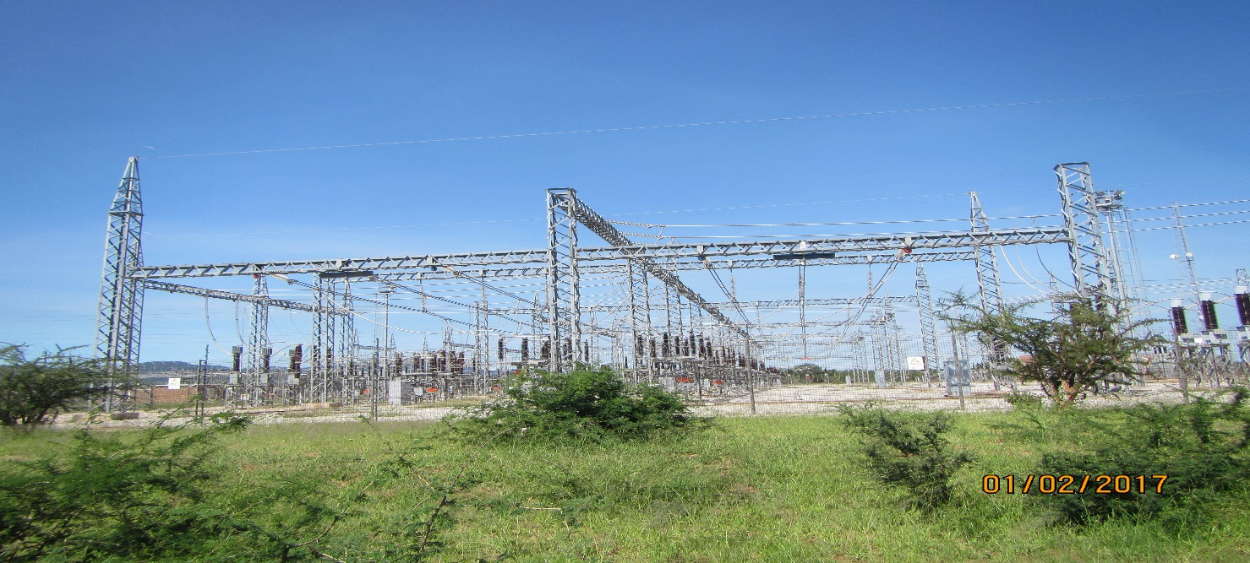
Figure 1: Foskor substation
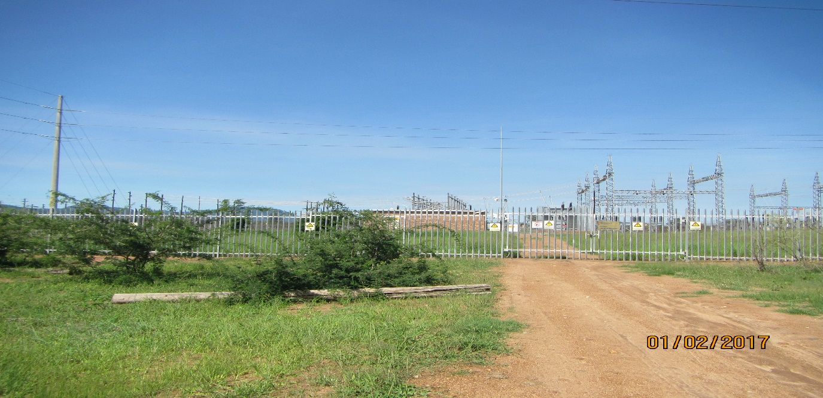
Figure 2: Spencer Substation

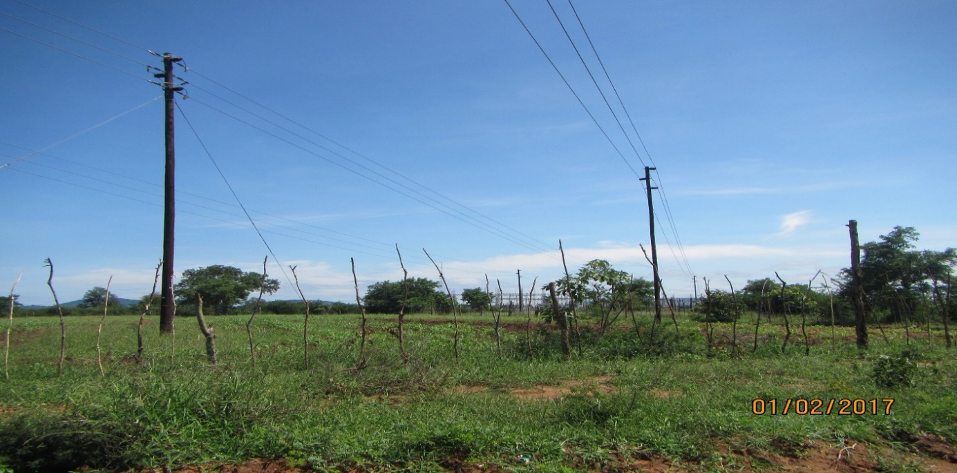
Figure 3: Cultivated Areas near Spencer Substation

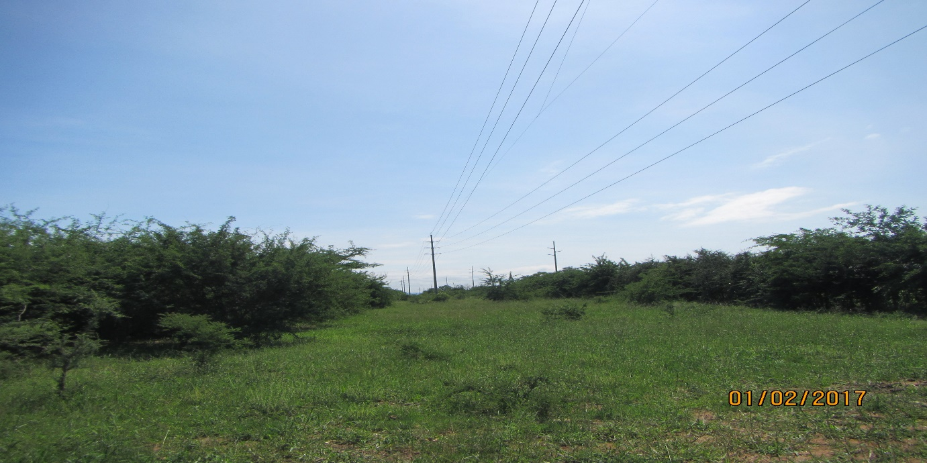
Figure 4: Corridor Alternative 2 will run parallel existing power line close to Spencer Substation

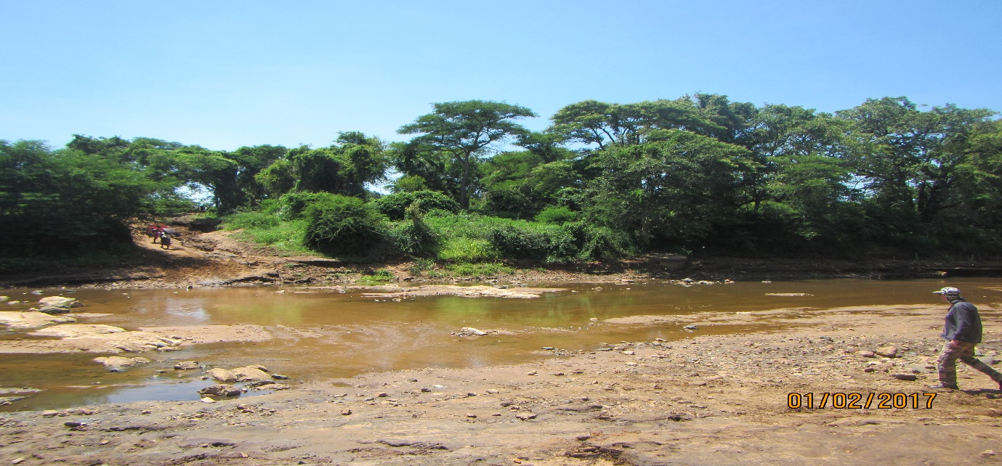
Figure 5: Both corridors will cross Molototsi River

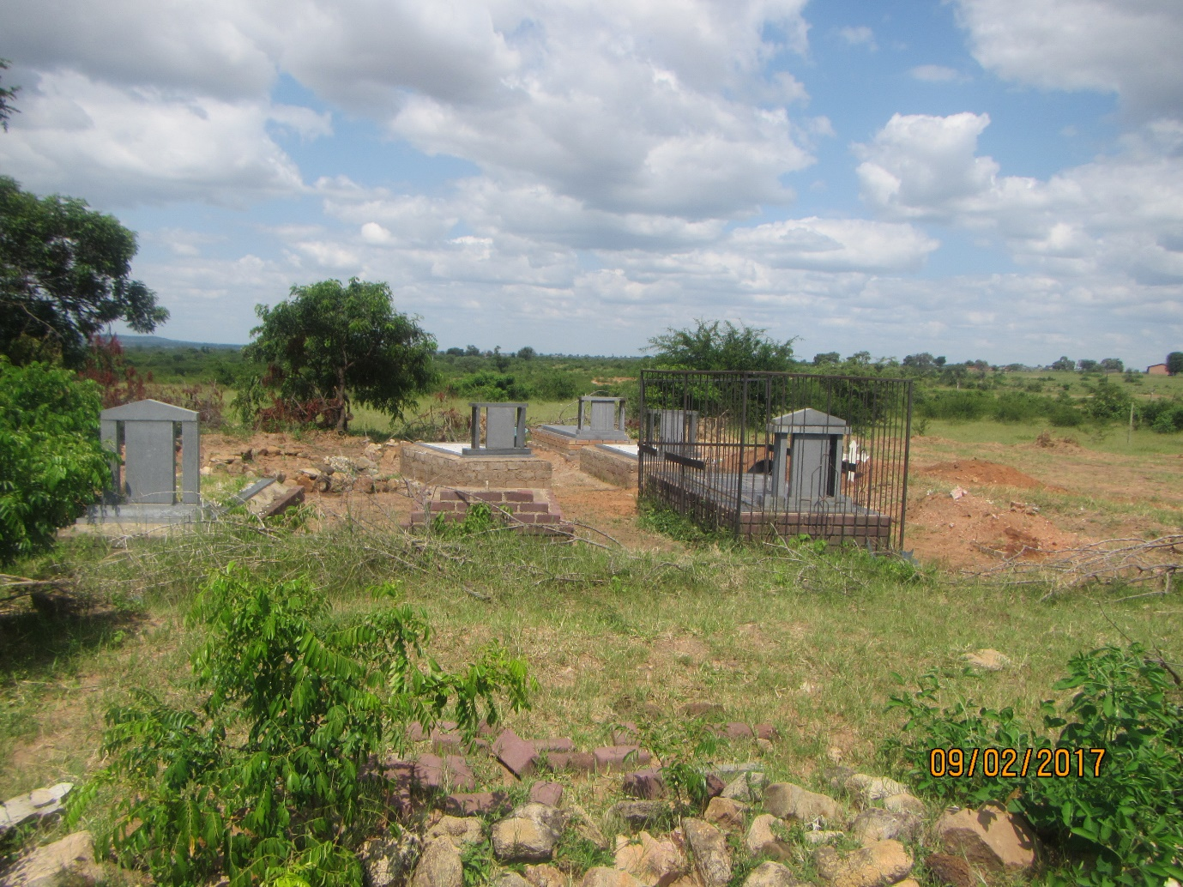
Figure 6: Cemetery at Ga-Mawa within both coridors

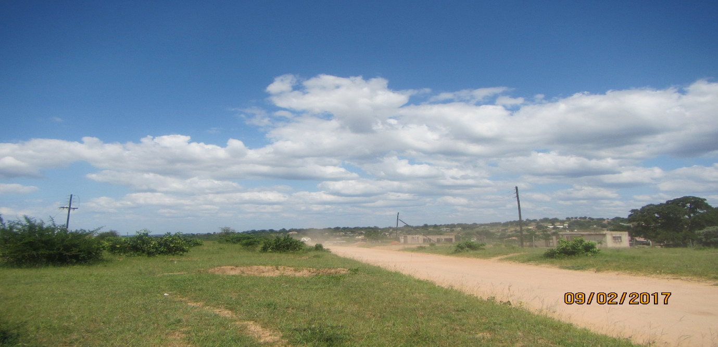
Figure 7: Ga-Mawa Block 7 within both corridor

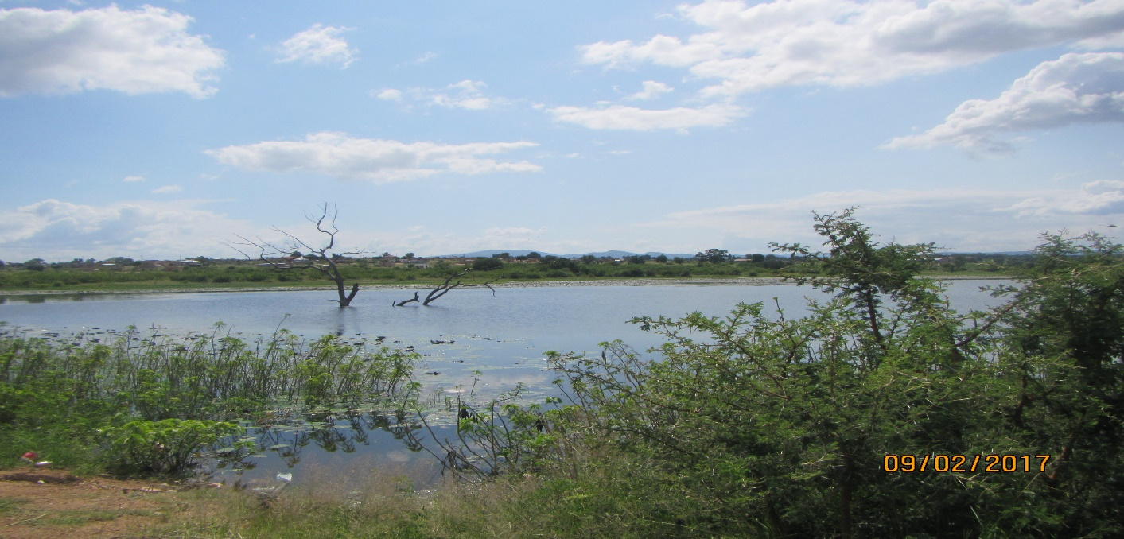
Figure 8: Dam near Nyakeni village (Within All Corridors)

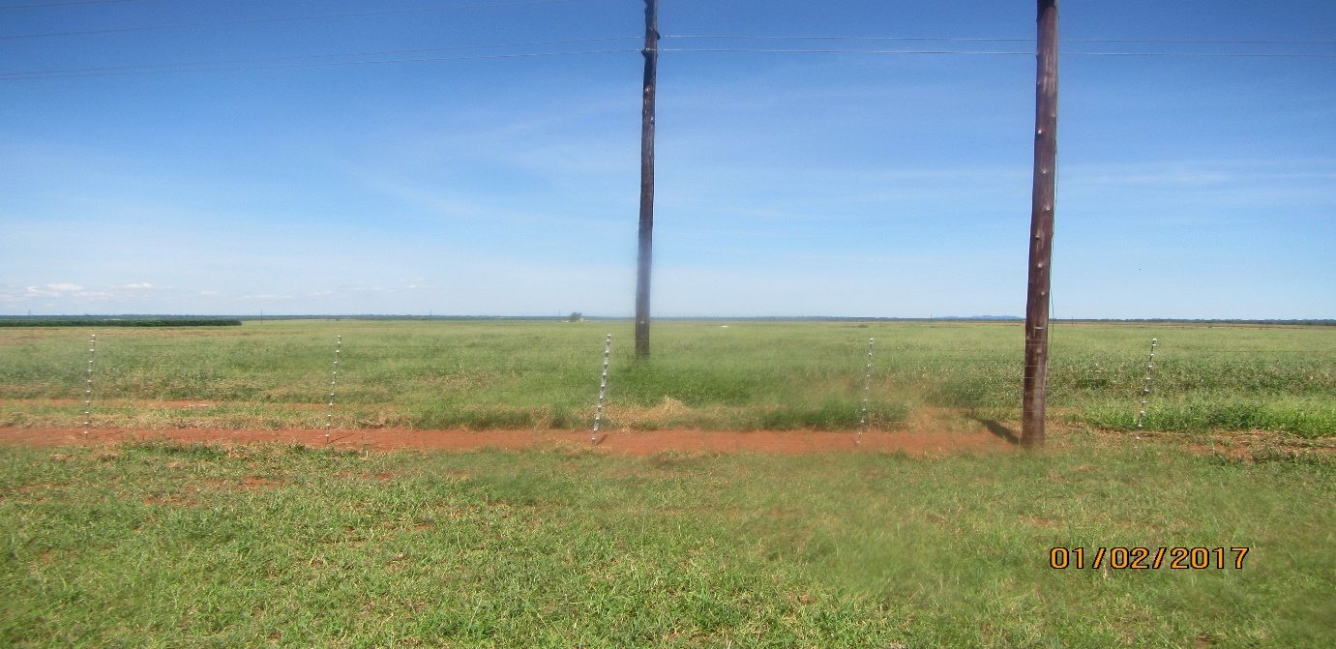
Figure 9: Agricultural Plot within Corridor Alternative 1 & 2

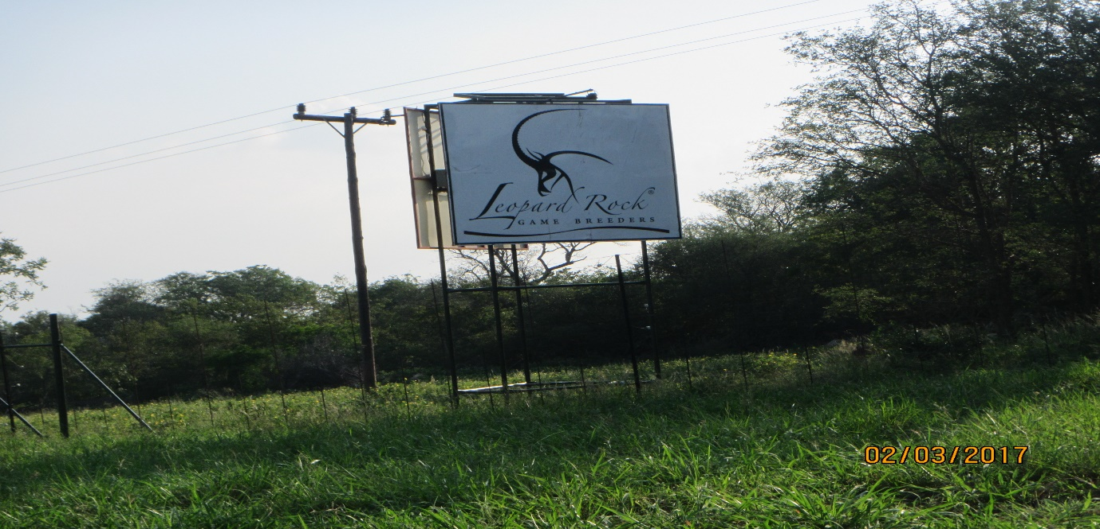
Figure 10: Part of Corridor alternative 2 is within Leopard Rock Nature Reserve

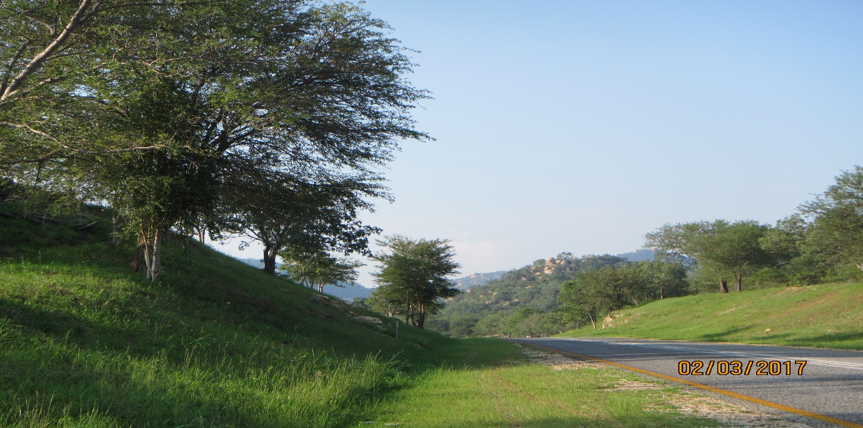

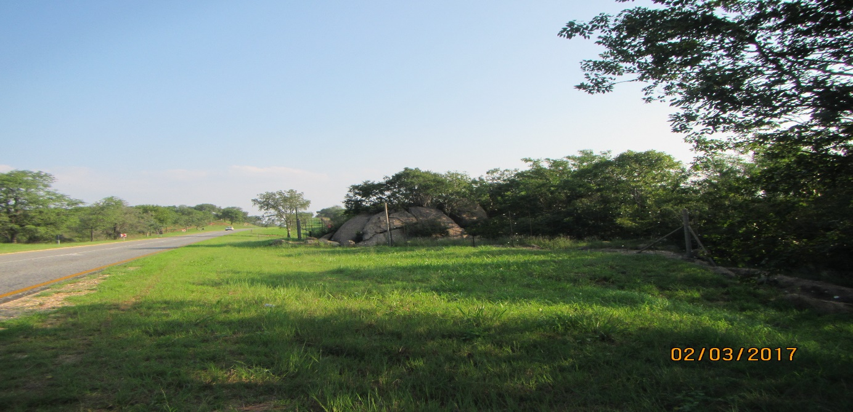
Figure 11 & 12: Rocky outcrops/low hills within corridor alternative 2

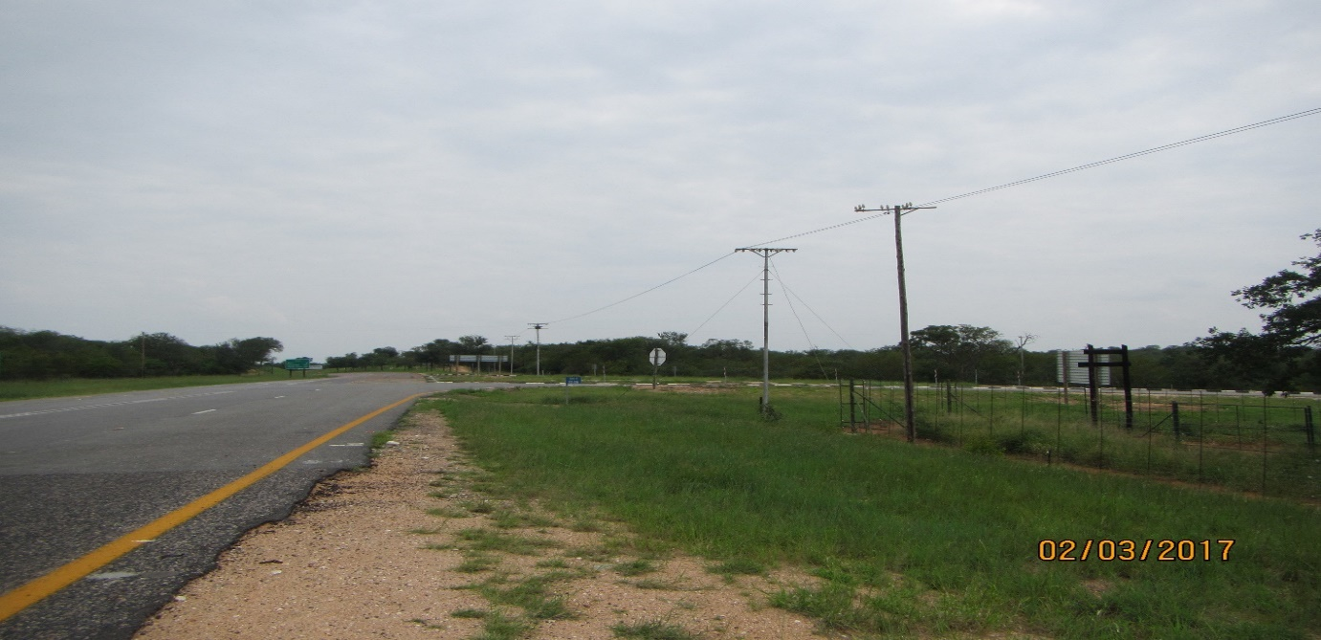
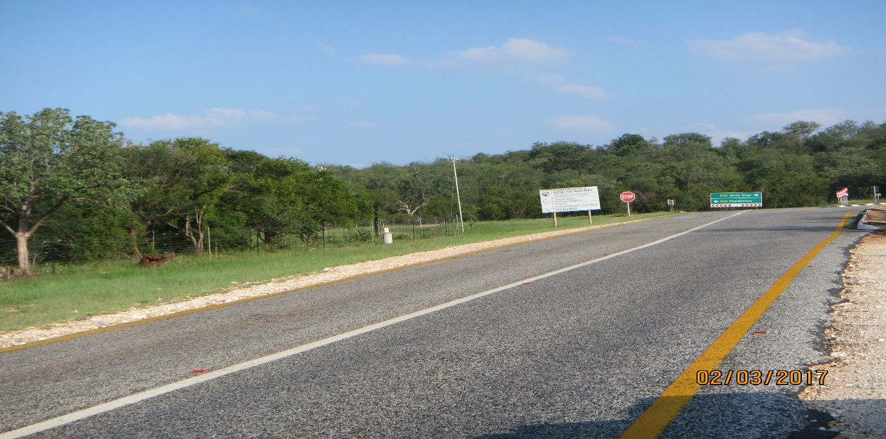
Figure 13 & 14: Corridor Alternative 2 will cross R40 and run parallel R526

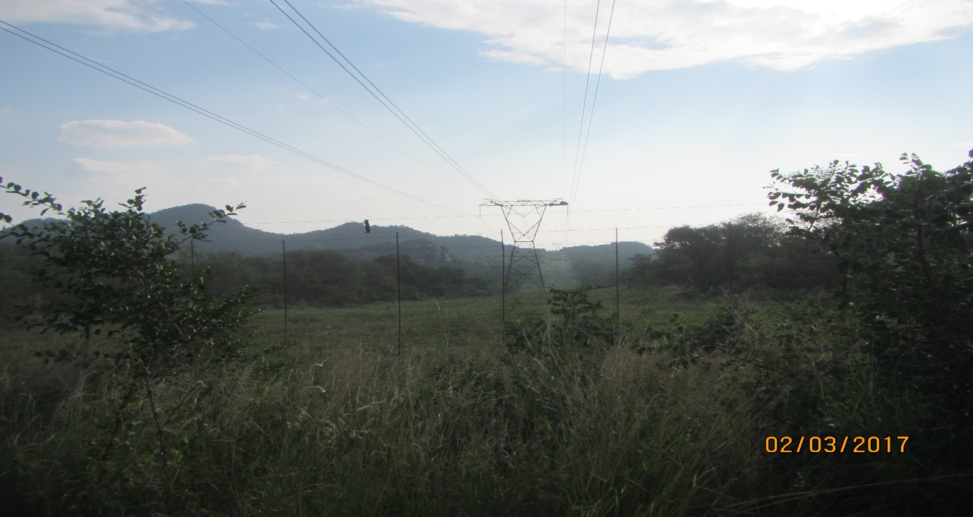
Figure 15: Corridor 2 will run parallel transmission line from Foskor substation

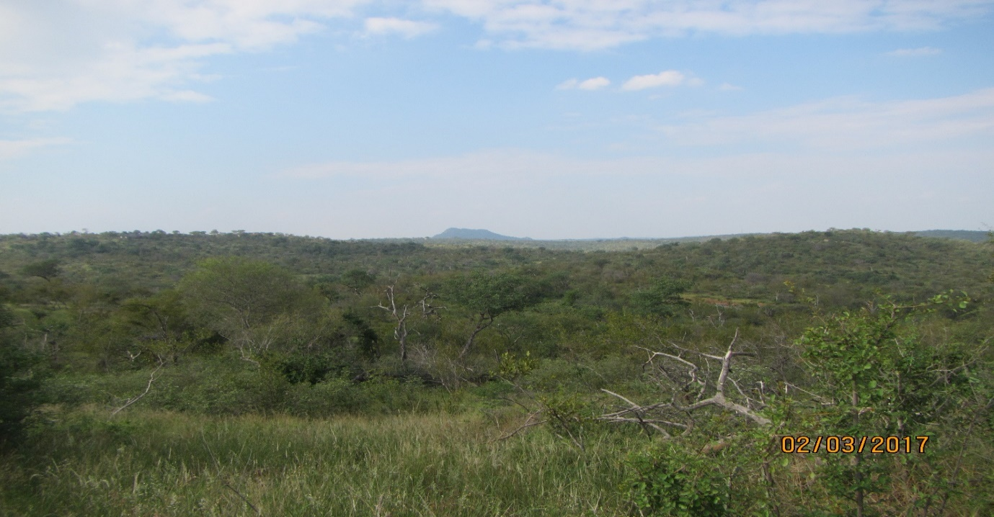
Figure 16: Area within the Balule Nature Reserve
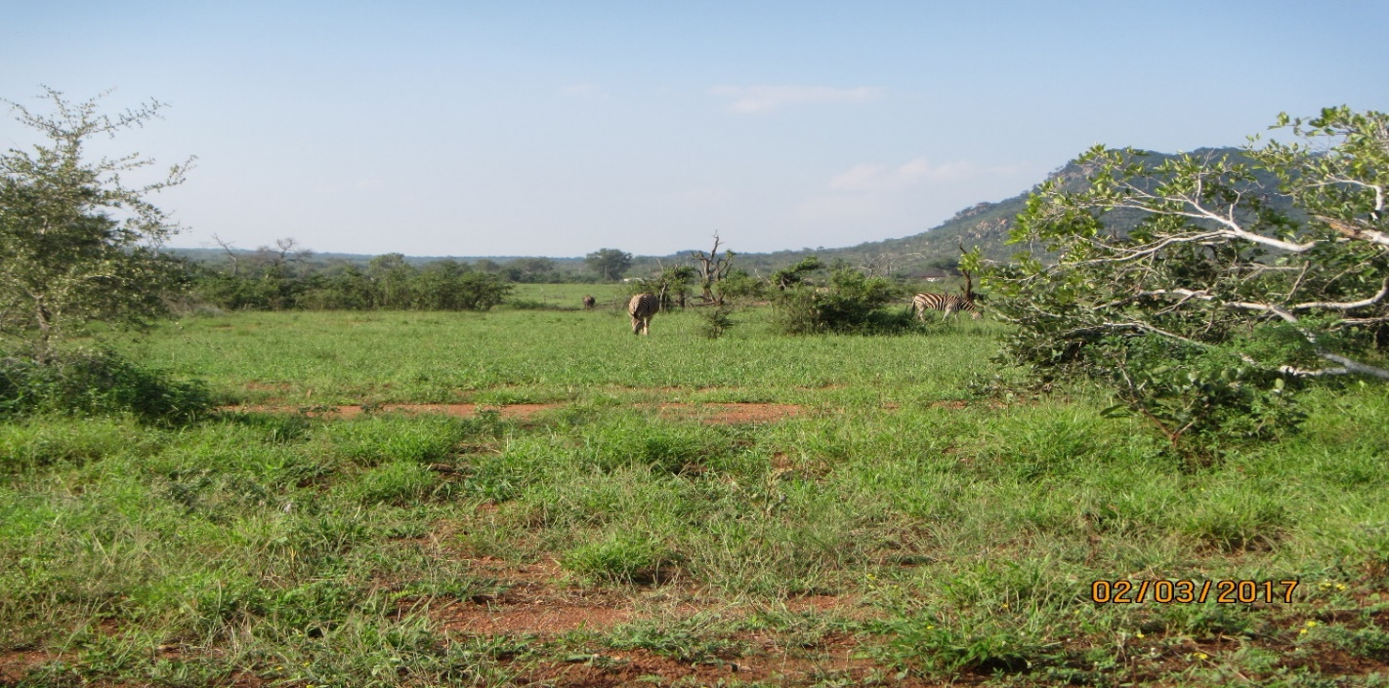
Figure 17: Area within Grietjie Farm

